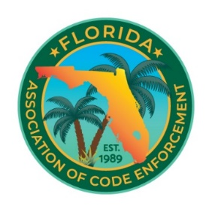

Florida Association of Code Enforcement
Board of Directors Virtual Meeting
March 12, 2026 at 12:00 PM – 4:00 P.M

- Call to Order

- Roll Call

- Approval of Agenda

- Approval of minutes

- Committee Reports from each VP/Committee Chair
- Past President Report
- Treasurer Report
- Ad-Hoc Committee Report
- Historian Reports-Cindy Drake
- Old Business
- New Business
- Good For the Organization

- Meeting of the Executive Committee

